**UNIVERSITÀ DEGLI STUDI DI TORINO**

|SCHOOL OF MANAGEMENT AND ECONOMICS|

Marjo Kaci | Simulation models for economics | Pietro Terna

Simulating Forex Market with NetLogo

[EUR/USD|Future|arbitrage]

# INTRODUCTION

I will analyze using NetLogo as tool for computer simulation, a complex system such as the foreign exchange market. It is fascinating how the currencies are determined and even more to understand how and what influences their fluctuation. As in every complex system analysis, I will start from some sampling assumptions and situations that will make possible to understand further more complicated and realistic ones.

I will simulate two markets, one that of a currency exchange rate spot and the other of a Future contract. A Future contract is an agreement to exchange (buy or sell) in a certain date in the future, a certain amount with a predetermined currency exchange rate. In order to implement the arbitrage price theory I calculate using the spot exchange rate, the expected future exchange rate according to the theory of interest rate parity, if the exchange rate according to this theory is not equal to the Future exchange rate I have an arbitrage possibility that can be exploited.

The core of this simulation will be that of analyzing the simulation of the spot exchange rate EUR/USD and that of the Future exchange rate. The interest rate theory is telling us that the interest rate differential between two countries is equal to the differential between the forward exchange rate and the spot exchange rate. Interest rate parity plays an essential role in foreign exchange markets, connecting interest rates, spot exchange rates and foreign exchange rates. Therefore, interest rates of the two currencies have a considerable influence and we will see how variations of these interest rates will affect the exchange rates.

Both the EUR/USD and the Future contract are simulated with their own negotiation book where buyers and sellers put their orders to buy and sell the commodity currency, which in our case is the EUR. In the case of the Future, the orders are to buy or sell with a certain exchange rate in the future our commodity.

I will also dedicate a part of this simulation to the technical analyses of the currency and in particular, I will focus on the Bollinger Bands and the Momentum strategies. These oscillators can be used to predict the movement of prices and implement active strategies.

# Forex market

The Foreign Exchange Market is considered the largest financial market in the world. Speculators, commercial companies, banks, central banks, hedge funds exchange everyday an average of $5 trillion a day.

My simulation consist on building two negotiation books where traders can put their buy/sell orders of the most exchanged currency ,the EUR/USD and a future on that currency. The negotiation book is like a book made of two parts, on the left side the demand(ask) of assets(in our case the currency) where we can put the prices to buy, on the right the supply(bid) where we can put the prices to sell. The orders are ordered starting from the best one for the buyer and seller and so on in a descending order to the worst ones. In the book, we can see the price of the buyers and sellers, if the price of the buyer I higher than that of the seller we negotiate.

The orders in the book are at the best and this is the only type of orders that I am considering. An order at the best means that traders buy/sell at the best price out there. I will not considering the limit orders where the trader accepts all the orders into that limit, for buyers the orders in limit are orders that buy all the quantity requested up to that limit, which in this case is the max price. In the case of sellers, they sell at limit, which is the minimum price of sale. I will not consider the Ton, iceberg orders or other type of orders that require a complicated book.

The negotiation happens according to some probabilities, we have a slider called out of market, which gives us the probability that the trader enters or goes out of the market. If we choose a low value of the slider, than the probability to enter into the market is that of a random number from zero to one to be smaller than the slider.

In addition, if the price is too high, we go out of the market and if it is too low, we go into the market.

if random-float 1 < out-of-marketLevel

[if exePricefuture > 1.6 [set out-of-market False]

if exePricefuture < 0.8 [set out-of-market True]

]

According to a probability, agents decide to buy, sell, or none of the two. With a slider called the passLevel we can choose the probability for the agents to negotiate or to be inactive, meaning that they do not sell nor buy.

We generate a random number from zero to one, if it is not lower than the passLevel then we do nothing, we do not negotiate. If it is lower, then we negotiate and we give equal probability to the agent to sell or buy this by first generating a random number from zero to one, if it is lower than 0.5 we buy if not we sell.

ifelse out-of-market [set color white]

[ifelse random-float 1 < passLevel [set pass True][set pass False]

ifelse not pass

[ifelse random-float 1 < 0.5 [set buy True set sell False]

[set sell True set buy False] ]

[set buy False set sell False]

if pass [set color gray]

if buy [set color red]

if sell [set color green]

In addition, I take note to who is the trader that makes the order with a specific price and the level of cash and stocks that each of the traders has, before and after every negotiation.

The book is made of the logB and logS where we can find the prices of the buyers and sellers:

if sell [set logS lput tmp logS]

if buy [set logB lput tmp logB]

The negotiation happens if:

item 0 (item 0 logBEUR/USD) >= item 0 (item 0 logSEUR/USD)

[set exePriceEUR/USD item 0 (item 0 logSEUR/USD)

let agB item 1 (item 0 logBEUR/USD)

let agS item 1 (item 0 logSEUR/USD)

If the best price in the logB is bigger of equal then the best price in the logS and we are selling then we set the exePriceEUR/USD the best price of the seller.

Then I take it off the book and take note for the price paid and money spend by the agent who:

ask randomAgent agB [set stocks stocks + 1

set cash cash - exePriceEUR/USD]

ask randomAgent agS [set stocks stocks - 1

set cash cash + exePriceEUR/USD]

set logBEUR/USD but-first logBEUR/USD

set logSEUR/USD but-first logSEUR/USD

Same way if we are buying.

# 2. Future

Beside the currency, I simulate also a future contract with its own negotiation book, but what is a future contract? A future is a standardized [contract](http://en.wikipedia.org/wiki/Contract) between two parties to buy or sell a specified asset of standardized quantity and quality for a price agreed upon today (the futures price) with delivery and payment occurring at a specified future date, the delivery date. In our case, we have a future on a currency, the EUR/USD, and the price is the exchange rate with which traders exchanges euros with dollars. This contracts is mainly used to eliminate the risk of the currency fluctuation, we can think of the international companies that are very exposed to this risk, they have costs of production mainly in developing countries with currencies that are very volatile and revenues in different countries.

In finance, traders use futures mainly for speculation purposes in many different ways, in this simulation we will see an arbitrage between the currency value capitalized and the exchange rate of the Future contract.

The futures are different from forwards because they are standardized. In this simulation, I will not consider some requirements of the future like the initial deposit that the two parts have to put as a guarantee. This is a complicated method called the marking to market that we are not considering since the purpose of the future in this simulation is that of demonstrating how the traders can exploit an arbitrage opportunity using a future contract and the interest rate theory. Also on contrary of an option, in a future, both parts must fulfill the contract on the delivery date.

The Future in this simulation will have its own book and will move according to some probabilistic rules that are similar to those of the currency book. The movement of the future will be totally different from that of the currency since will represent a certain exchange rate in the future.

# 3. Interest rate parity

Interest rate parity is a no-arbitrage condition representing an equilibrium state under which investors will be indifferent to interest rates available on bank deposits in two countries.

The fact that this condition does not always hold allows potential opportunities to earn riskless profits from covered interest arbitrage. In our case we will see how to get the expected future spot exchange rate of our currency according to this theory and check if it is in line with the Future contract exchange rate, if not then we have an arbitrage opportunity to exploit.

Given foreign exchange market equilibrium, the interest rate parity condition implies that the expected return on domestic assets will equal the exchange rate-adjusted expected return on foreign currency assets. Investors then cannot earn arbitrage profits by borrowing in a country with a lower interest rate, exchanging for foreign currency, and investing in a foreign country with a higher interest rate, due to gains or losses from exchanging back to their domestic currency at maturity.

Here we assume that the foreign exchange market equilibrium is respected and the exchange rate at the end is that according to this theory. We are not exploiting a carry trade opportunity but just identifying what will be the currency value at the end if the market is in equilibrium. I cannot make a profit by borrowing in countries with low interest rate and investing that amount in a country where the interest rate is high, this because at the end the exchange rate between this two countries’ currencies will be such that my profit will be zero.

In this simulation, we will see also how movements of the interest rate can influence expected future spot exchange rate and so under no arbitrage influence also the future exchange rate.

*C:\Users\HOM\Desktop\09b4158d9bb8f097ff07dc64aee93489.pngUncovered interest rate parity*

where

E_t(S_{t + k}) is the expected future spot exchange rate at time *t + k*

*k* is the number of periods into the future from time *t*

*St* is the current spot exchange rate at time *t*

*i$* is the interest rate in the US

*ic* is the interest rate in a foreign country or currency area (for this example, following a US perspective, it is the interest rate available in the [Eurozone](http://en.wikipedia.org/wiki/Eurozone))

The dollar return on dollar deposits, 1 + i_\$, is shown to be equal to the dollar return on euro deposits, \frac {E_t(S_{t + k})} {S_t} (1 + i_c).

*Covered interest rate parity*

The Ft is the exchange rate according to the future when we cover our self by purchasing a future:

(1 + i_\$) = \frac {F_t} {S_t} (1 + i_c)

If the E_t(S_{t + k}) is different from the Ft then we have an arbitrage opportunity that we are going to exploit in our simulation.

# 4. Arbitrage

I will introduce the arbitrage not as an emerging result of the agents operations but as a representative of the simulated values of the two assets with and without the presence of arbitrage. The arbitrage can be activated using a switch and its effect can be seen in these lines of code:

if (not empty? logBfuture and not empty? logSfuture) and

item 0 (item 0 logBfuture) >= item 0 (item 0 logSfuture)

[ifelse ARBITRAGE[set exePricefuture EUR/USD-future][set exePricefuture item 0 (item 0 logSfuture)]

let agB item 1 (item 0 logBfuture)

let agS item 1 (item 0 logSfuture)

If the switch is on the price of the future contract will be that of the EUR/USD-future and if not then the value simulated is different from the EUR/USD-future.

# 5. Technical analyses

Since I have created a full negotiation book I will also try to simulate some indicators and oscillators of technical analyses, in particular we will see the Bollinger Bands and the Momentum.

Bollinger Bands

John Bollinger invented the Bollinger bands oscillator in the 1980s, this oscillator is made of a moving average over the prices for a determinate number of periods, in this simulation I will consider a moving average over the entire time series. In addition, we have two bands, the above band, made of the moving average plus 1.96 times the standard deviation. The below band, made of the moving average minus 1.96 times the standard deviation. Since this oscillator assumes that prices are distributed as a normal, the 95% of the prices are between these two bands and when they are outside there is a tendency to go back inside the bands.

This can be used by traders to implement active strategies by betting on this strategy. However, traders have different approaches in exploiting this strategy and for this; we are not focusing on the strategy to implement but rather in the simulation of these bands for just a technical analyses and not for buying or selling that currency. As in every other oscillator or indicator they are not used alone, usually trading signals can be found if more than one indicator tells us so. Also important news in the market like the interest rate changes by central banks, as we are simulating, are moments where this kind of strategies do not work.

Momentum

The momentum is an oscillator used to identify the speed of a trend. History has shown us that momentum is far more useful during rising markets than during falling markets, the fact that markets rise more often than they fall is the reason for this. It has also been proved that stocks with strong past performance continue to outperform stocks with poor past performance in the next period with an average excess return of about 1% per month.

The market momentum for ‘n’ periods is calculated by the making the difference of the actual price and that of n periods before, times 100.

M(t) = P(t) - P(t – n)

Where:

P(t)=actual price at time t

P(t-n)= price pf n days before; n= number of days(periods)

Here we have an example of the Momentum Indicator(MI):

|  |  |  |  |  |  |  |  |  |  |  |
| --- | --- | --- | --- | --- | --- | --- | --- | --- | --- | --- |
| **Price** | 120 | 127 | 132 | 134 | 134 | 131 | 126 | 120 | 122 | 128 |
| **MI** |  | 7 | 5 | 2 | 0 | -3 | -4 | -6 | 2 | 6 |

For representation purposes, we divide the MI values by the max price of the period and multiply it by 100.

If you are a regular trader you tend to use low value of n(the nr of periods) and if you are a longer term investor you tend to use higher one.

Trading signals:

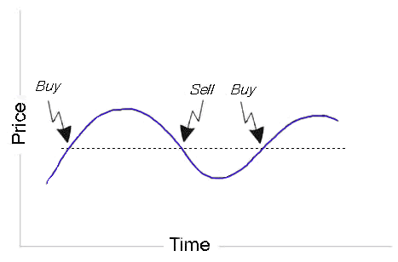

When it passes the 0(zero) line graphically represented with dots in the picture we can find some trading signals as represented in the picture.

Other trading signals are those in divergence with prices. When we find some minimum prices that are descending and minimum values of the momentum that is ascending, then we have a divergence and we expect a change in the trend. Same for maximum prices.



It can also be used to confirm the trend, if we don’t have a divergence we can assume that the trend will continue.

# 6. Results

The result of this simulation is first the exchange rate EUR/USD that we wanted to simulate. As we can see in the picture below the fluctuation is totally random for each time that we lunch our simulation.

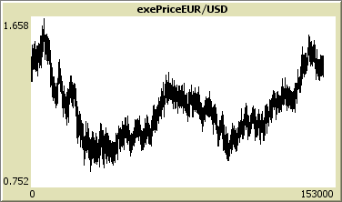

We will be using this currency simulation to calculate indicators and oscillators whose fluctuation will mainly be determined by the fluctuation of this currency.

We use this simulated exchange rate to calculate the exchange rate in the future according to the interest rate parity:

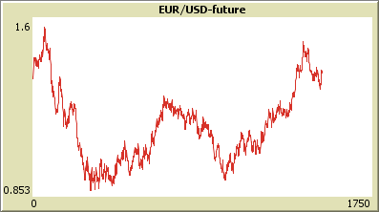

The fluctuation of the EUR/USD-future are mainly determined by the fluctuation of the EUR/USD. The fluctuation differs when we change the interest rate as we can see in the picture below:

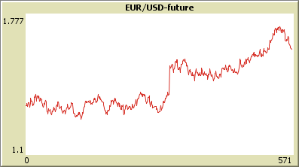

Using the sliders for the interest rates, we can see the influence that the changes of the interest rates bring to the expected exchange rate in the future.

I also simulated a Future contract on the EUR/USD with its own negotiation book and a fluctuation totally independent from that of the currency.

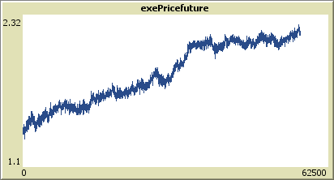

An important thing to try out is that of the arbitrage when we turn on the arbitrage switch. We can see how the price of the Future contract aligns with that of the EUR/USD-future :

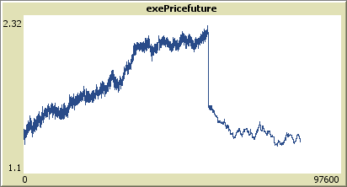

As we allow for arbitrage opportunity we can see how the price changes drastically.

As for the momentum, I already explained the strategies used by traders; here we can see some concrete possibilities:

|  |  |
| --- | --- |
|  |  |
|  |
|  |

In the above graph, we can see the divergence strategy. Another strategie is that when the momentum passes the zero line.

DIVERGENCE

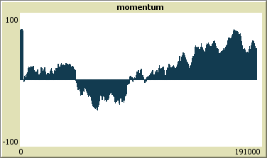

Sell buy (not so successful) buy

Another oscillator that I simulated here is that of the Bollinger Bands, made of a moving average over the EUR/USD and two lines, below and above the moving average.

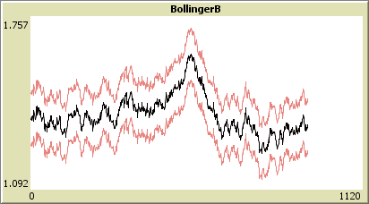

The strategies that can be implemented using the Bollinger bands are those when the price goes outside the two bands and we expect a return inside even why we cannot know for sure. This kind of strategy works well for titles that are not so volatile and are in a stationary situation. It does not work that well when important news are announced.

# 7. Conclusion

In this simulation, we saw how to simulate the forex market using NetLogo as an agent-based modeling (ABM). This is a bottom-up simulation where we start from the bottom, from the agents that in our case are representative of the traders that negotiate in the forex. These traders place their order to buy or sell that currency and therefore, they negotiate, arriving so to the top of the simulation that is the exchange rate that we wanted to simulate. However, it is not just a bottom-up model we can see also the influence that changes in the interest rates have on the expectations of the traders, so we see a how a top-down policy like that of the a central banks can have on the currencies.

Another conclusion is that of the alignment between the prices of two assets when there is an arbitrage opportunity in the market. We see when we turn on the switch that the two prices, that of the expected future exchange rate and that of the future become equal. This is a result of the arbitrage that the agents

One of the conclusions that I arrived is related to the limitations of ABM in capturing psychological and comprehensive aspects of the agents. For example, the prices that the agents put into the book are totally uncorrelated with the fact that they are experiencing a recession or an expansion, in reality this is a very strong factor that influences prices. In addition, the expectations are also very difficult to be implemented, this also because information among agents is not equal meaning that there are specialized agents and less specialized ones with different expectations.

By analyzing the oscillators that I created we can notice that simulated prices might not have the same the same meaning as those in the real life. We can see this by looking at the momentum strategy, which assumes that assets that performed well in the last “n” period will continue to do so. This is a result of quantitative research but we cannot say so for simulated values since they move according to probability lows.